Criterion C: Development

Word Count: 950
Techniques Used
The development of the price tracker required many techniques including the ones mentioned during criterion B. I will go over each technique, the rationale, sources (when applicable) and annotated screenshots for evidence.

XMLHttpRequests
The core functionality of the chrome extension relies on the program’s ability to actually fetch the information about a product from the Amazon website. Thankfully, since JavaScript is the language being used in the chrome extension there are many different approaches to scraping web pages (retrieving the HTML of a website). I chose to use the XMLHttpRequest method rather than the alternatives due to the fact it has been around for the longest period of time and is relatively easy to understand.
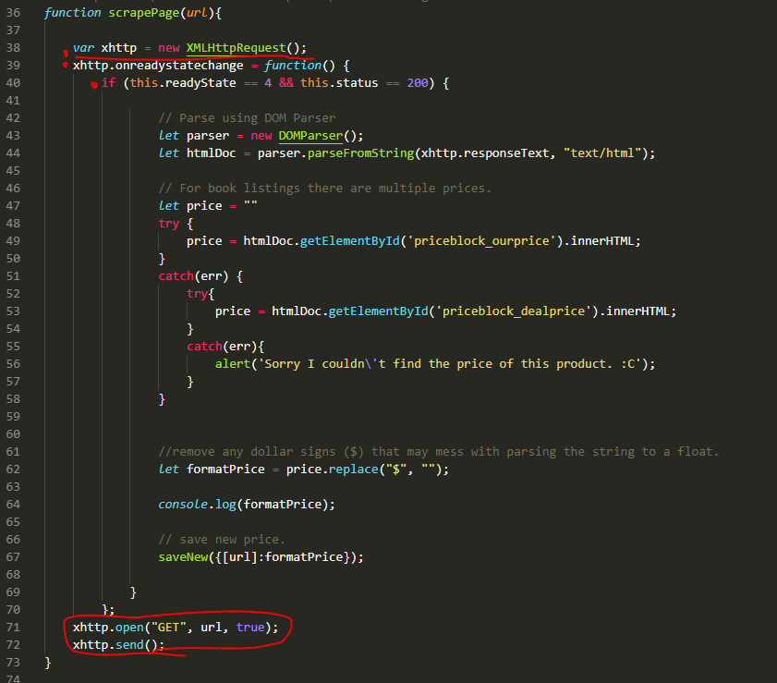As can be seen from the screenshot above the an XMLHttpRequest is used to retrieve the HTML of a given URL by sending out a “GET” http request. The callback function “xhttp.onreadystatechange” is used to specify what happens when a response is given from the server, which the website is located on. Furthermore, to prevent possible errors with processing a malformed response the program checks to make sure the process from the XMLHttpRequest object has finished by testing the the readystate which if at “4” signifies that the process is completed.

In the same line the program tests to make sure the return HTTP code is 200, which would mean the request has completed. The complete list of HTTP response codes is documented by standard RFC 2616 by the IETF (Internet Engineering Task Force).

DOM Parser
The retrieved HTML however is useless if the program cannot access the relevant information. Luckily this is possible thanks to the usage of the DOMParser, another built-in JavaScript object. This allows the program select particular elements based on their class, id or tag name as if the JavaScript was modifying the HTML as an embedded script.

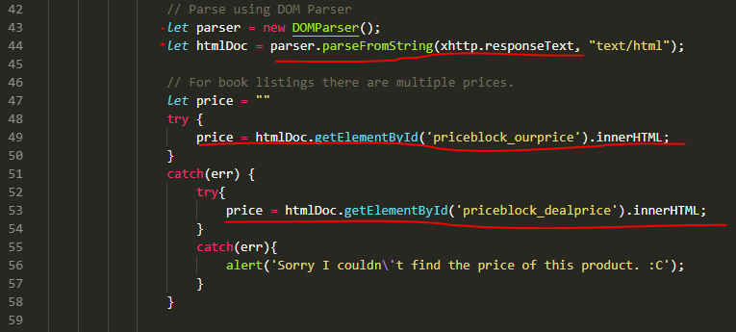

The variable “parser” holds an instance of the DOMParser which is then referenced in the subsequent function calls. In addition a basic algorithm is used to insure that a price is scrapped from the page by using a “try-catch” pair which attempts to execute code and then upon an error executes another block of code rather than pause execution of the script.

This is necessary due to Amazon being inconsistent in the classnames of their prices between both book sales and regular products.

Chrome.storage.sync
Chrome.storage.sync is the built-in function for chrome browsers which in this program is used to store the URLs and previously saved prices of Amazon products. This method stores data in a dictionary format. In which values are unordered and may be referenced by non-integer indexes. The list of page URLs and prices are stored themselves in their own dictionary which is referenced by the string literal “AmazonURLS”. So the expanded data structure may look something like this:

{
“AmazonURLS”:{
“amazon.com/bike”: “$34.11”,
“amazon.com/bucket”: “$23”,
“amazon.com/thing”: “$99.99”
}
}

The sync method was chosen over the more commonly used Chrome.storage.local method as sync allows the data to be accessed from across browsers. Meaning the program will remember products saved on a different chrome browser instance.

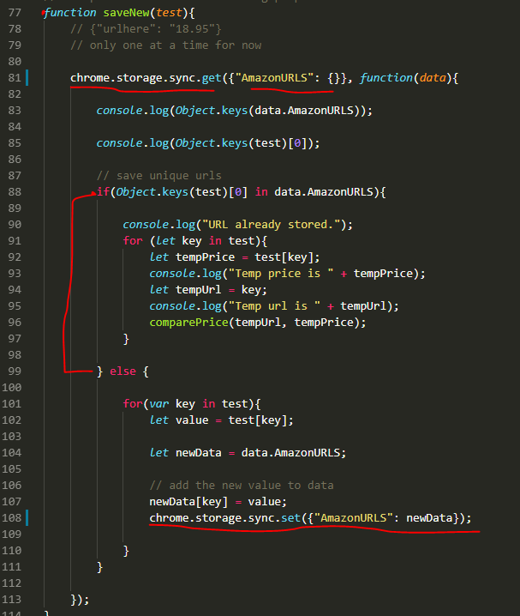

Chrome.tabs.query
This is another built-in chrome function which returns information relating to the tabs a user has opened in their browser.

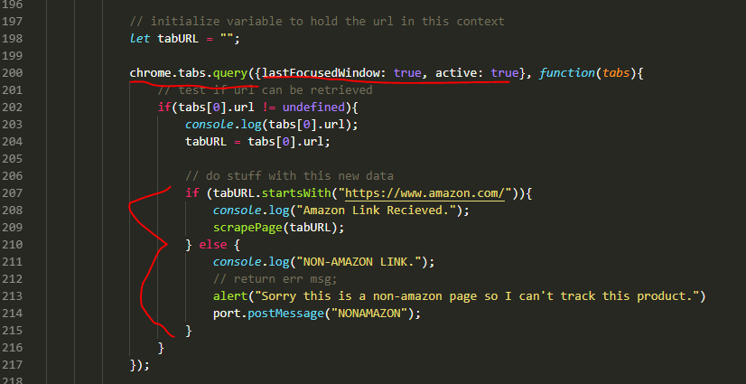
It was used to find the url of the user’s window. The URL then goes through an if/else statement pair to determine if the url is from Amazon and can have the price data scrapped.

Long Lived Connections
The chrome extension needs to let the background.js script know when to execute various functions based on the user’s input in the HTML files. Like when the user presses a button in the extension to save a new product the background script needs to check the tab url, see if the url is an amazon url that go through the algorithm to determine if the price can scraped and saved OR if the product has already been saved in storage.

The extension achieves this through Long Lived Connections which is a fancy term for having one script msg another script. See screenshots below for reference.

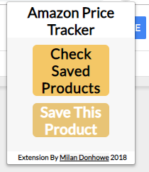 When the button is clicked by user, it triggers an event listener for the javascript file for the HTML file, popup.js, which sends a message to the background.js script that is running in the background.
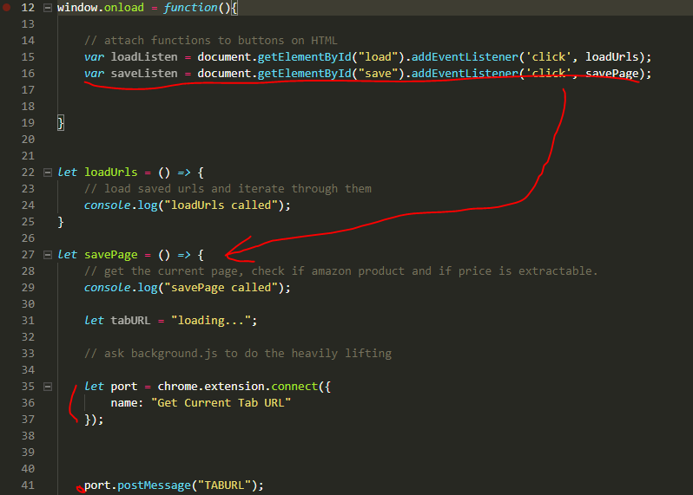
This message is then received in the background script.
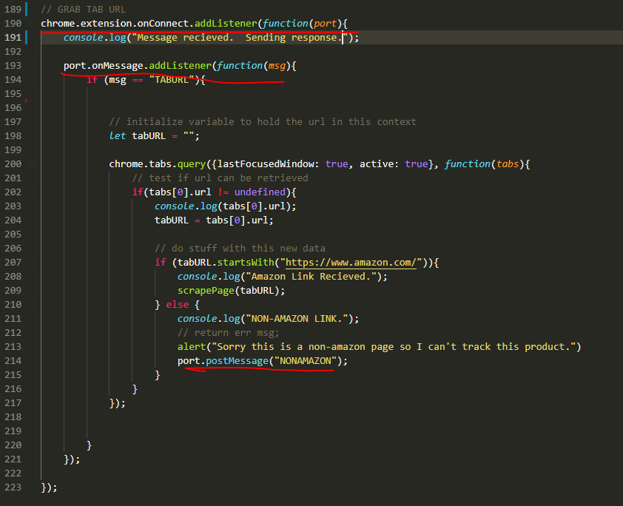

Regular Expressions
Some regular expression logic is used for displaying the saved product name. Since only the URL and price is stored a simple regular expression was used to extract the product name or part of the name from the URL to be displayed visually for the user.

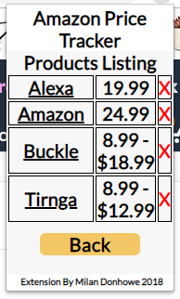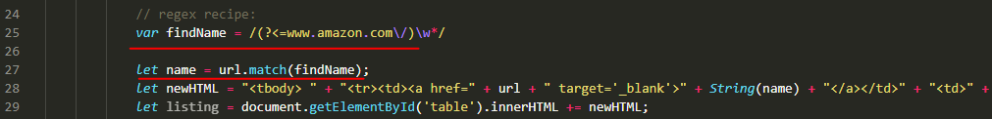
innerHTML
Used both in DOMParser to retrieve the HTML data from amazon websites and used to dynamically change the markup of the extension page. The evidence for the usage can be seen in the above images.

HTML/CSS files
The entire user interface for Chrome Extensions is built off of HTML, (Hypertext Markup Language) and CSS (Cascading Style Sheet) which are the primary technologies used for visual web development. This was helpful as there was plentiful documentation on the usage but also because the technologies themselves are designed specifically for being user interfaces.

The popup.html is the first and main visual file loaded which has the elements of the page organized.
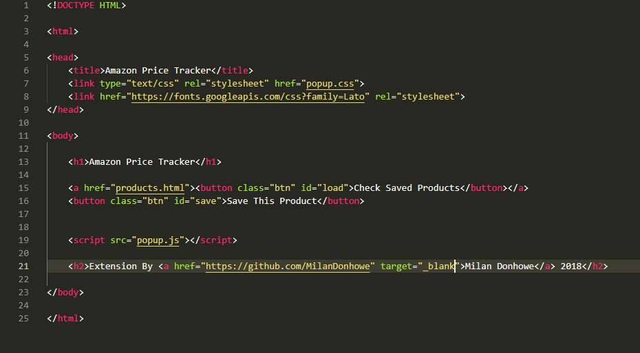
The CSS file specifies parameters for the rendering engine of the chrome browser. This includes the font-size, color of text, background color and other visual aspects.
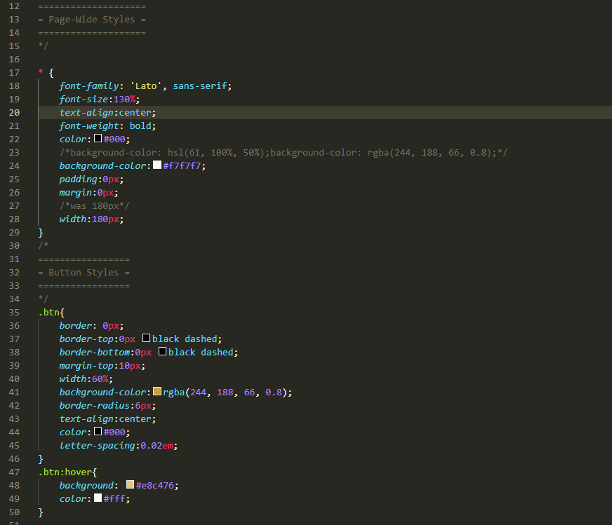
Manifest.json This is the configuration file for the chrome extension. Specifies various parameters like the icon and permissions of extension.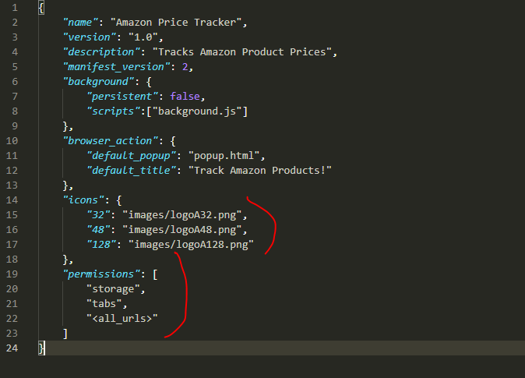

alert()
A common JavaScript function which is used to notify user of errors in the extension or new deals detected.

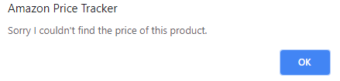

Works Cited:

Browser Statistics, www.w3schools.com/jsref/jsref_obj_regexp.asp.
“Chrome.storage.” Chrome: Developer, developer.chrome.com/extensions/storage.
“How to Fetch URL of Current Tab in My Chrome Extension Using Javascript.” Stack Overflow, stackoverflow.com/questions/18436245/how-to-fetch-url-of-current-tab-in-my-chrome-extension-using-javascript.
“Hypertext Transfer Protocol (HTTP/1.1): Semantics and Content.” IETF Tools, tools.ietf.org/html/rfc7231#section-6.
“Parse an HTML String with JS.” Stack Overflow, stackoverflow.com/questions/10585029/parse-an-html-string-with-js.
“XMLHttpRequest.readyState.” MDN Web Docs, developer.mozilla.org/en-US/docs/Web/API/XMLHttpRequest/readyState.

